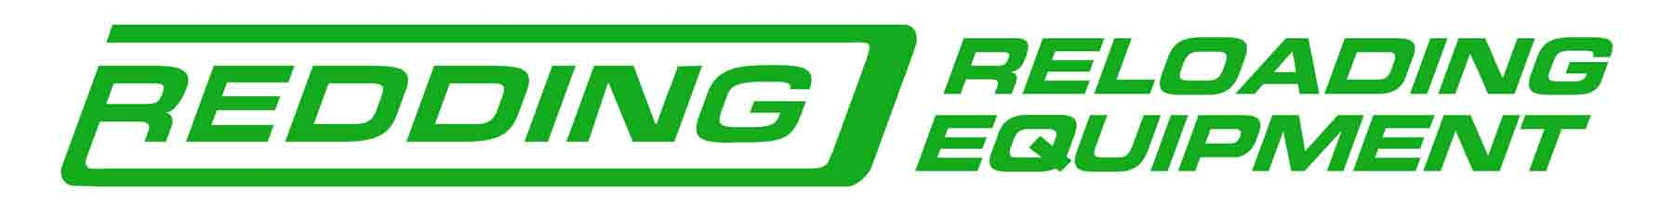

Writer Organization Profile of
Redding Reloading Equipment

Contact: Robin L. Sharpless,
Executive Vice President
robin.sharpless@redding-reloading.com

Address: 1089 Starr Road
Cortland, NY 13045
Phone: (607) 753 - 3331
Fax: (607) 756 – 8445

Bio: Redding Reloading Equipment is a premier manufacturer of reloading equipment for metallic rifle and handgun cartridges. The company has a long history of innovation and the development of unique and Patented products, which may be used to produce the finest and most accurate hand loaded ammunition possible. All Redding products are made only in their Cortland, NY facility, from American Steel, with Castings from Pennsylvania and on 100% American Made machinery. A qualified Writer Program is available allowing active members of established Outdoor Writer Organizations and those with masthead positions at shooting and hunting publications, to purchase Redding products at 50% off of current catalog list. Consignments are available and will be reviewed on an individual basis.

Redding offers numerous unique solutions to improve the accuracy, consistency and reliability of your handloaded ammunition. For more information and our current color catalog contact: Redding Reloading Equipment 1089 Starr Road Cortland, NY 13045, or visit us on the web at: www.redding-reloading.com.

2016

